**Name: Nikhil Jadhav**

**Student ID: 801075504**

1. INNER JOIN Statement:

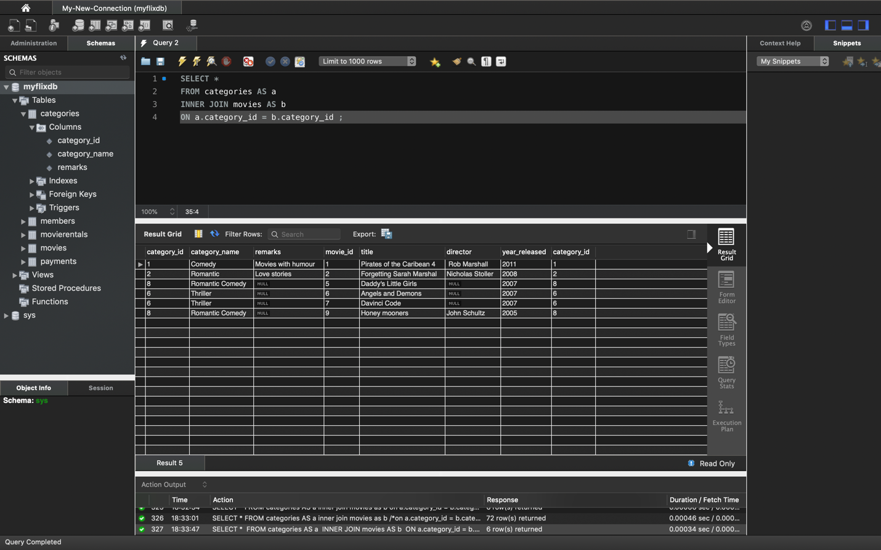

1. LEFT OUTER JOIN Statement:

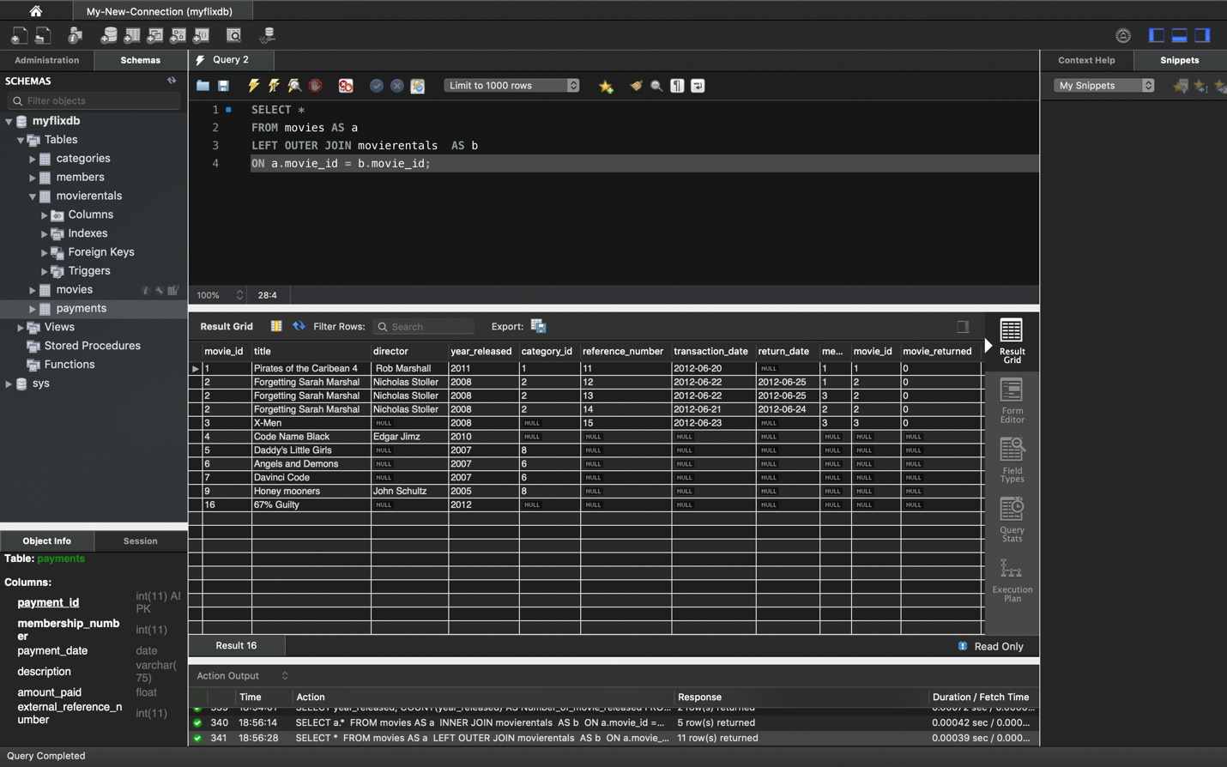

1. SELECT statement with 6 or more attribute.

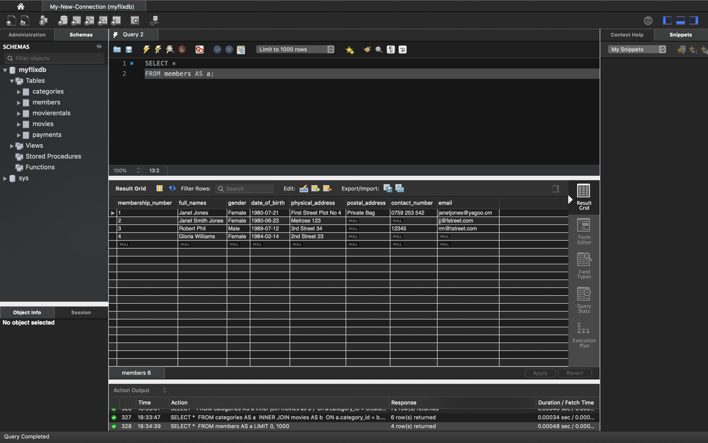

1. SELECT statement with 6 or more attribute:

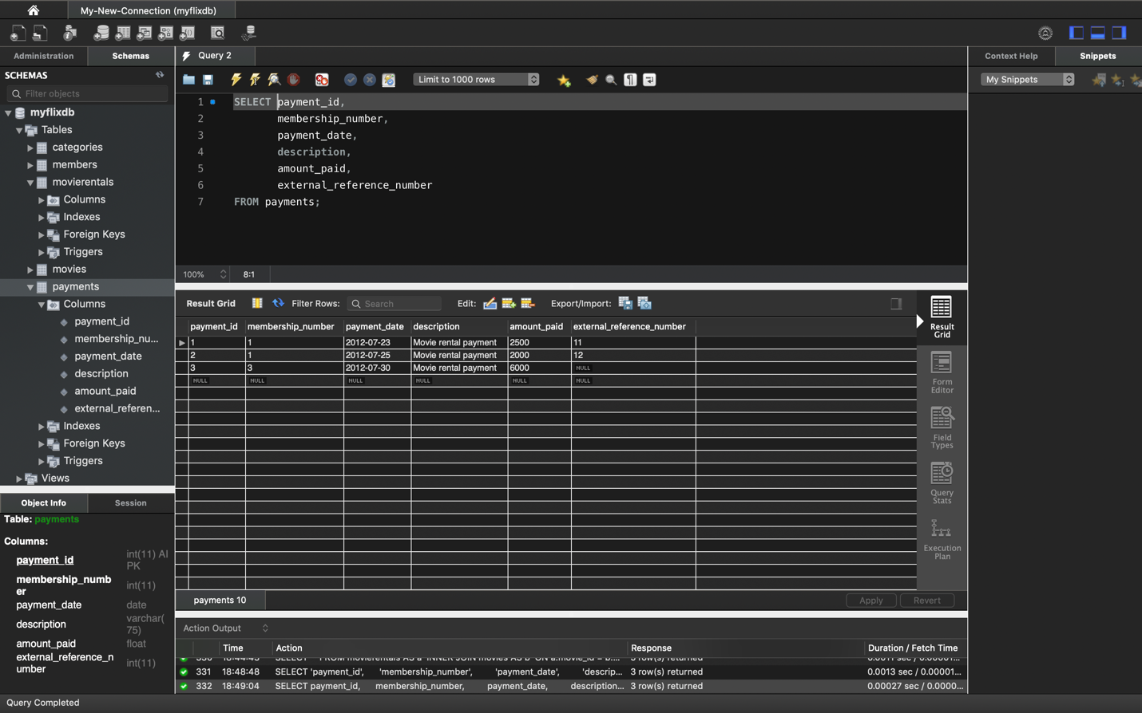

1. GROUP BY Statement

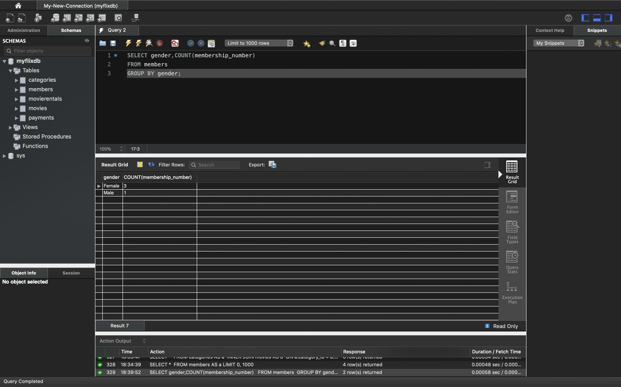

1. GROUP BY and HAVING Statement.

